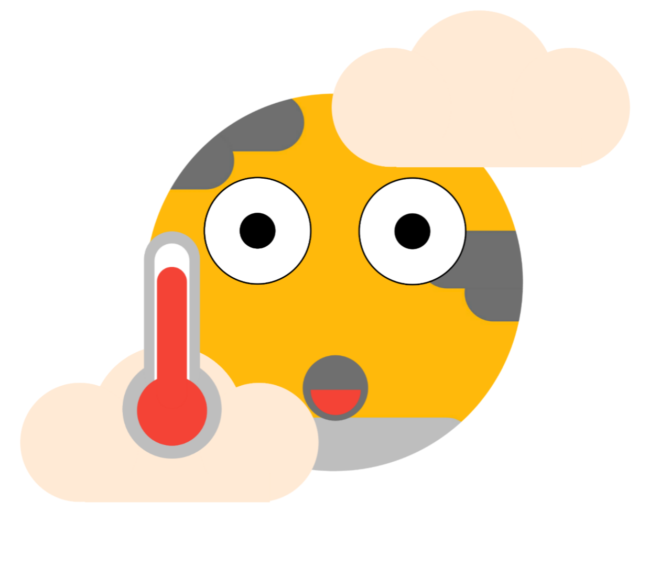
THE BLUISH PLANET
2/30

THE CARBON VERSION

THE CARBON FOOTPRINT REDUCER (TCFR) VERSION

Hot earth illustration
by amarnath.p


WHAT TO ADD FIRST TO YOUR TASKS.

Do you know what is the first thing to add to your tasks for reducing your carbon footprint, save earth, save your and your loved ones future.

Now let's continue…..

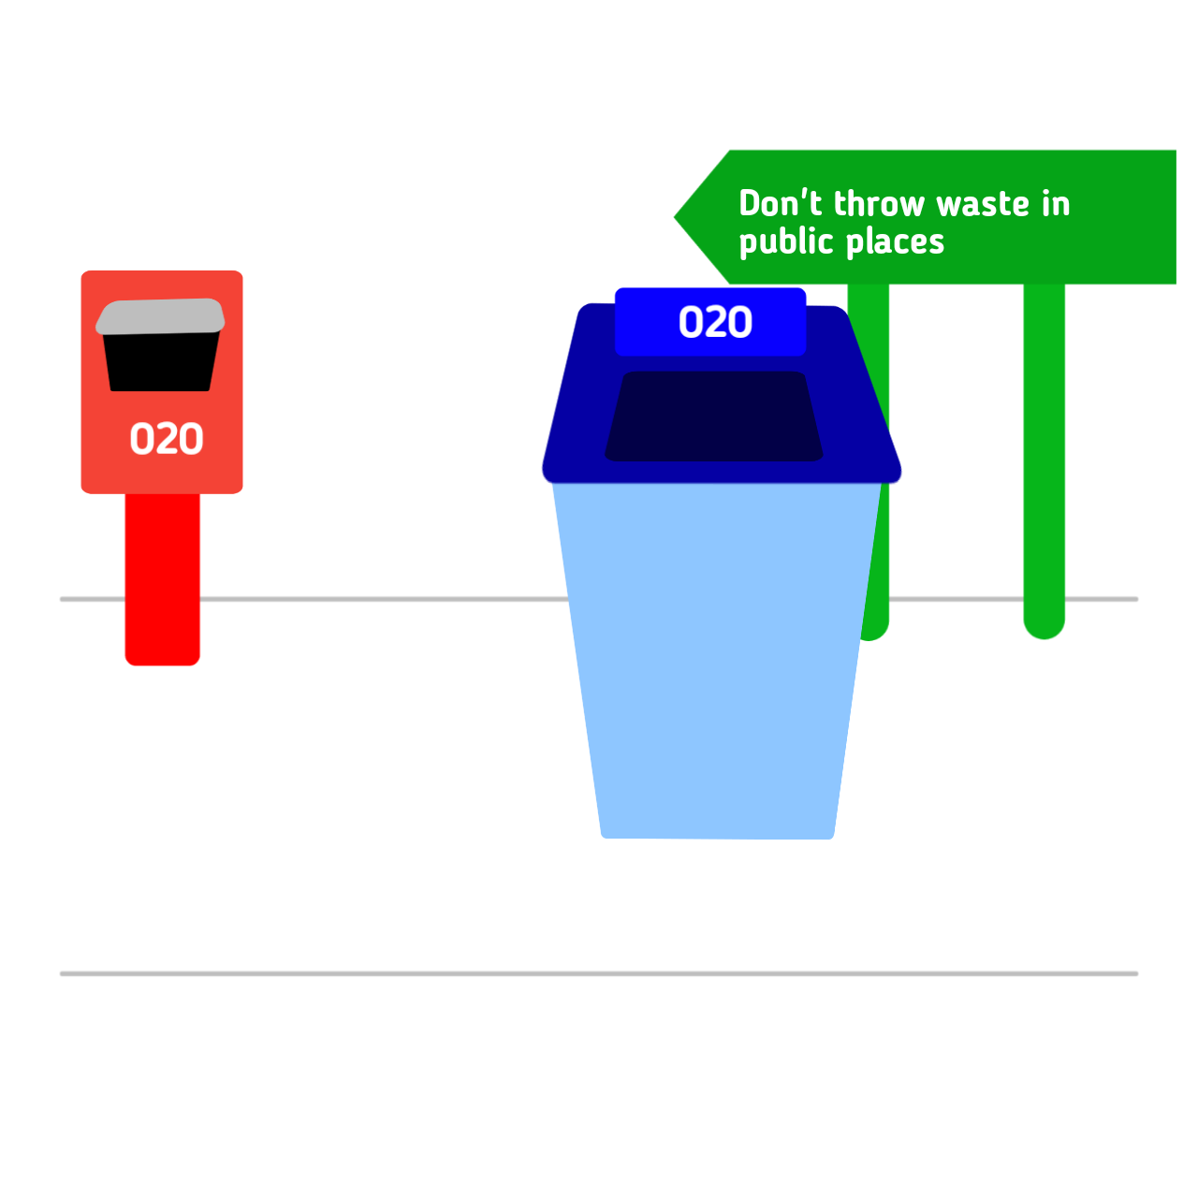

THE FIRST THING TO KNOW "5 R's".

At least some of you may know 5 R's isn't it. Although if you don't know. 5 R's means "refuse, reduce, reuse, rot, recycle"

Going zero waste is a great step towards combating climate change. Practicing the 5 R’s of zero waste can help. You’ve probably heard of the three R’s: Reduce, Reuse and Recycle. But there are two more that are equally important.
NOW LET'S BREAK THE " refuse, reduce, reuse, rot, recycle ".

REFUSE: Avoid single use plastics and paper products by saying no thank you, opting for reusables.

REDUCE: Downsize what you purchase, opting to be more mindful of what you really need.

REUSE: Always find a way to keep an item out of the landfill by keeping it in great condition, repairing or upcycling it when it breaks.

ROT: Set up a compost system for your food scraps, or find a food scrap drop off center (like a farmers market, or community garden) near your house.

RECYCLE: Properly recycle any plastic, paper, glass or metal that comes into your life you cannot refuse, reduce, or reuse by researching your state’s recycling laws.

Now I think you may have learned "5 R's" If you don't know it.


CONCERVE WATER

Did you know 96.5 percent of the water on earth is too salty for human consumption? Two thirds of the remaining fresh water are locked away in polar ice, glaciers, and permanent snow.

Melting it won’t help, seeing as most of it will just end up as sea water. That’s why it’s so important to cherish the water we have.

SOME WAYS YOU CANREDUCE YOUR WATER USAGE.

Turning off the tap while brushing teeth is a great example of a little thing that makes a big difference. Doing this saves gallons of water per day. Just imagine the amount of water you save when multiplied by the number of people in your household! You could also consider shortening your shower time (shortening it by two minutes can save more than 10 gallons of water), inspecting and fixing leaky faucets immediately, and using a professional car wash (since they use less water) instead of washing your car yourself.

Avoid dish/body soaps filled with toxins. Conventional dish and body soap contain ingredients that go down the drain and only further pollute our water supply.

Host or join a waterway cleanup in your local community. Keep those waters plastic free.

Opt for reusables. Lots of disposable items take gallons of water to make.

There are several other products, like paper plates, cups and towels, that gallons of water to make as well.
SWITCH TO SUSTAINABLE CLEAN ENERGY.


fossil fuels are limited, finite resources and just the transportation of them alone can cause air pollution.

When the fuels are burned, they emit toxins that speed up climate change.

There is good news though! You can help stop our reliance on fossil fuels by switching to sustainable energy today. There are so many amazing, innovative ways to source energy in this day and age.

Solar and wind power are just a few (though, by far the most common): There’s also water and geothermal power to consider.

SOME WAYS TO SWITCH TO CLEAN ENERGY

Install solar

panels on your roof: This is the most expensive option, but a good one if you feel you can make the investment.

Talk to a professional and a trusted company before making the leap. Your own utility may even offer installation.

Join a community solar farm

This is a lot more feasible if you’re on a budget. Or don’t have a suitable roof.

The solar farms are remote and don’t require you to install anything on your property. In return, you’ll see savings on your energy bill over time.

Sign up for energy saving programs: Many utilities are beginning to offer programs that will help you reduce your energy usage, and save a buck.

See if yours offers any you can take advantage of.

Cut down on electricity use altogether

No matter what you decide to do, using less electricity is always the best option.

Invest in more energy efficient products (I personally only buy products with the energy star logo on it), and make sure to shut off lights when you’re not in a room. Pull plus out when not in use too.

Buy an electric car: When it comes time to buy a new car, instead of buying a traditional car, why not buy electric? If it’s too out of budget, consider buying a used EV or hybrid instead.

STREAM LESS QUALITY VIDEOS.


STREAM less quality videos sunch as 360p or 144p as you wish it would help you reduce some carbon footprint.



PLANT TREE
PLANT a tree Ewen while you can't reduce your carbon footprint but you can definitely help earth survive.


SEARCH INTERNET FOR MORE
SEARCH INTERNET FOR MORE INFORMATION BASED ON IT.

SEARCH " HOW TO REDUCE CARBON FOOTPRINT "

BLUISH PLANET PART 2


THE END

SOURCES

THE EBOOK IS WRITTEN BY AMARNATH.P (OWNER OF ONE2ONE)

The information are based on the knowledge of amarnath.p, adhithyan.m.k & some open sources based on ONE2ONE or educlick (such like Quotes, utter, educlick learn and utter ftf).

MORE

IMAGE SOURCE.

MOST OF THE ILLUSTRATION ARE CREATED BY AMARNATH.P AND SOME ARE FROM UNDRAW.CO WEBSITE.

ADVERTISE
To advertise in the next part contact email : educlick.gsoft@gmail.com

Advertisement starts from 0.2 US dollar

NEXT PART

Next part is based on how to reduce mining and more of reducing carbon footprint. Increasing internet speed.

BASICS
The book is based on how we can save our mother planet earth and some tips. Written by amarnath.p in 2021 fabraury 3 (ACCORDING TO INDIA).

An

ONE²ONE
PRODUCTION

WRITTEN BY

AMARNATH.P

PUBLISHED BY

UTTER•

INFORMATION

APV 2020

Build on Google DOCS (ANDROID)

